**End-users document**

Group Name: personal information management

**Requirement**

In this document is will be talking about our project requirement, to ensure that we met the requirement, we will be looking at points such as what the project is, the server need and the purpose of the project.

* **Project description**

The business has many employees and all their information and details are stored within the company. All the information’s are personal they need to we keep the security. To ensure that the security business has decided to create a personal information management application to secure the management of employee information.

* **Service need**

The business has needed a way to securely manage their employees personal information. An application to manage the information has been shown as the most effective method to ensure the secureness of employee data. Therefore, the project is created to meet that need.

* **Project purpose**

The purpose of this project is to design and create an application that will manage personal information of employees within a company. The application will allow the adding , editing and deleting of details when needed. The purpose of the GUI is to promote and improve the management of personal information. Support users by making it easier for them to view their information. Secure and management user’s information thought making charges and limiting accessibility to data.

**Requirement**

The main requirement will be for the application to meet the users need , for that to meet all the little requirement need to be met.

* Functional requirement

1. Add employee’s information
2. Edit employee information
3. Delete employee information
4. Employee can look at their information

* Usability requirements

1. The application will fully function in different application such as computer and laptops.

The GUI will also need to meet the following requirement have the following in order to meet the project requirement.

* The GUI will have login (username and password) with restricted access

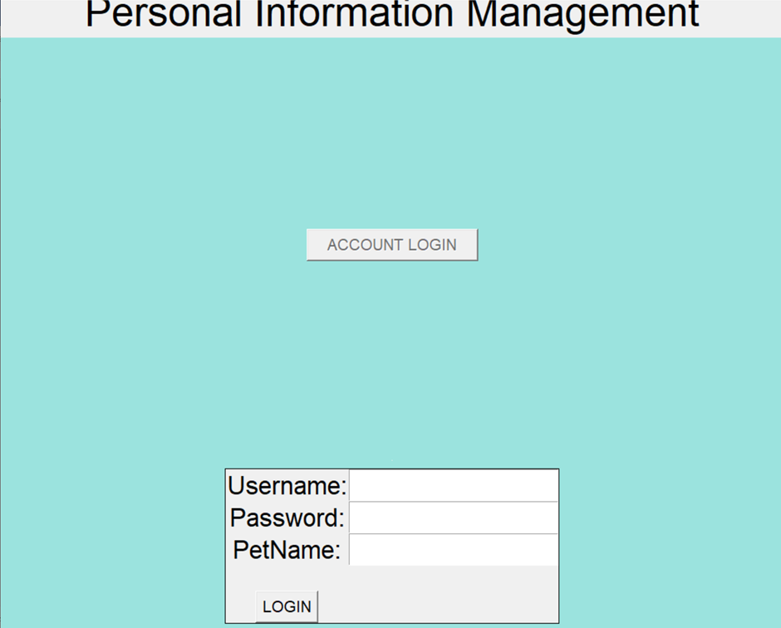

* A policy check to accept before login.

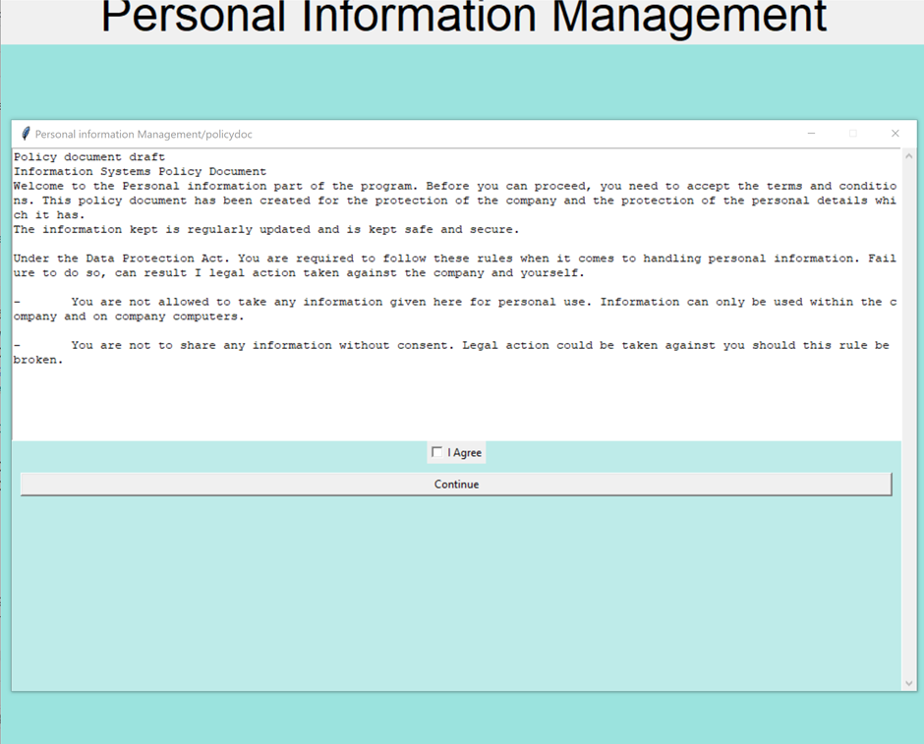

* Once login users can view their account or employee

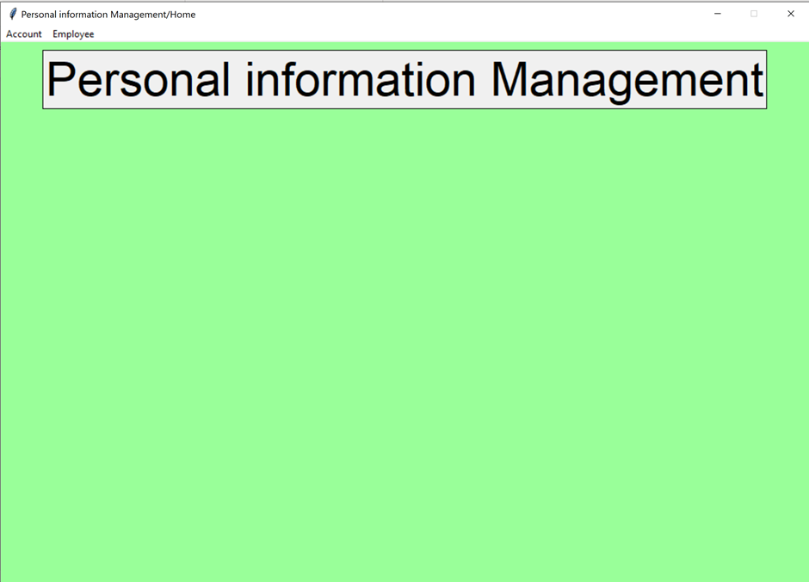

* The employee menu will allow then to either view or add an employee detail

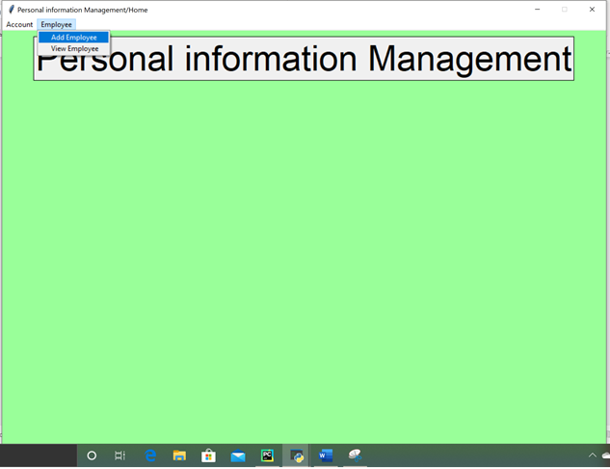

* The account menu allows users to logout or exit

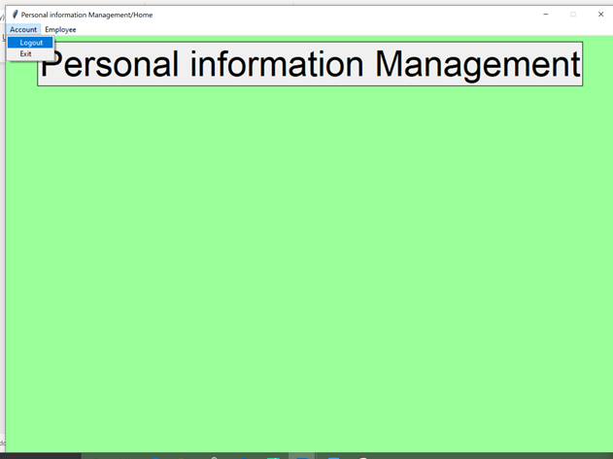

* When exit button click message box “you sure you want to exit “Yes to exit

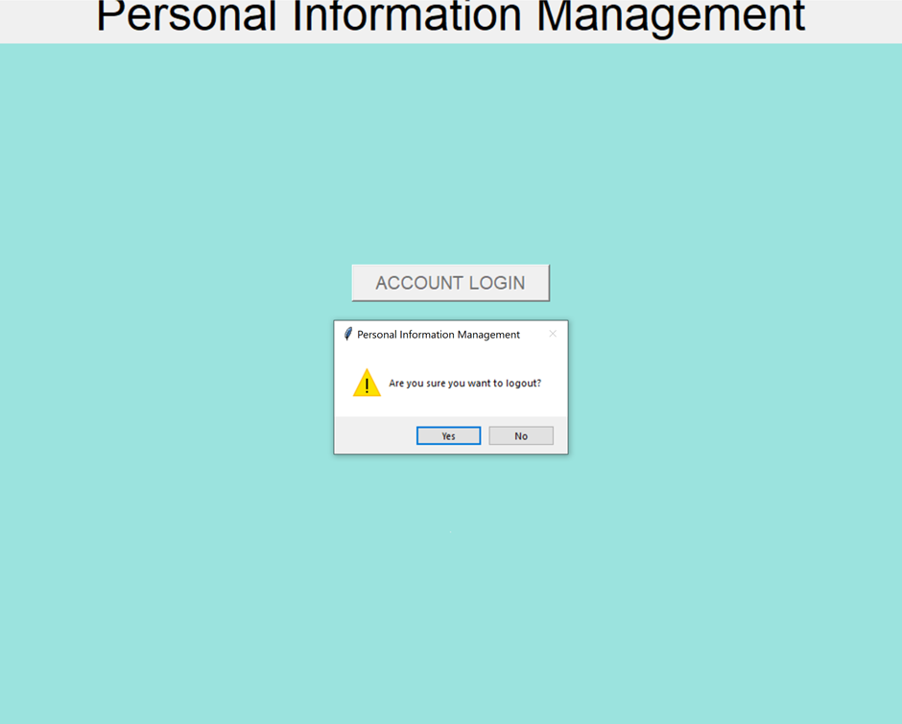

* Check whether users can login to add new information, delete and search for data.

